**1. Record macro to customize Quick Access Toolbar with following listed features**.

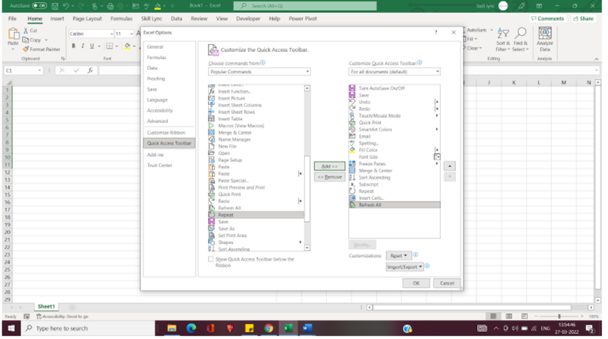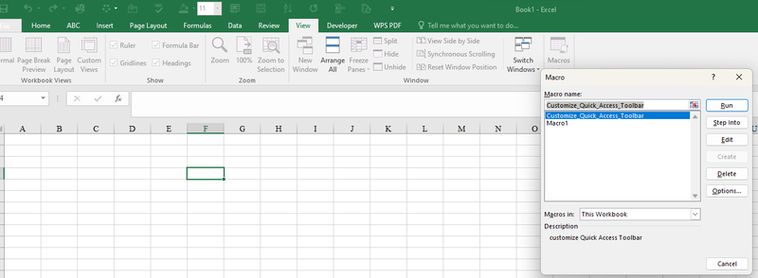

**CODE FOR THE ABOVE QUESTION (**customize Quick Access Toolbar)

Sub Macro1()  
'  
' Macro1 Macro  
' Mine  
'

'  
Range("I6").Select  
ActiveCell.FormulaR1C1 = "S.No"  
Range("J6").Select  
ActiveCell.FormulaR1C1 = "ID"  
Range("K6").Select  
ActiveCell.FormulaR1C1 = "Age"  
Range("L6").Select  
ActiveCell.FormulaR1C1 = "Rank"  
Range("I7").Select  
ActiveCell.FormulaR1C1 = "1"  
Range("I8").Select  
ActiveCell.FormulaR1C1 = "2"  
Range("I7:I17").Select  
Selection.FillDown  
Range("I7:I8").Select  
Selection.AutoFill Destination:=Range("I7:I17"), Type:=xlFillDefault  
Range("I7:I17").Select  
Range("I8").Select  
ActiveCell.FormulaR1C1 = "2"  
Range("I7:I8").Select  
Selection.AutoFill Destination:=Range("I7:I16"), Type:=xlFillDefault  
Range("I7:I16").Select  
Range("I17").Select  
ActiveCell.FormulaR1C1 = ""  
Range("I6:L16").Select  
Range("I14").Activate  
Selection.Borders(xlDiagonalDown).LineStyle = xlNone  
Selection.Borders(xlDiagonalUp).LineStyle = xlNone  
With Selection.Borders(xlEdgeLeft)  
.LineStyle = xlContinuous  
.ColorIndex = 0  
.TintAndShade = 0  
.Weight = xlThin  
End With  
With Selection.Borders(xlEdgeTop)  
.LineStyle = xlContinuous  
.ColorIndex = 0  
.TintAndShade = 0  
.Weight = xlThin  
End With  
With Selection.Borders(xlEdgeBottom)  
.LineStyle = xlContinuous  
.ColorIndex = 0  
.TintAndShade = 0  
.Weight = xlThin  
End With  
With Selection.Borders(xlEdgeRight)  
.LineStyle = xlContinuous  
.ColorIndex = 0  
.TintAndShade = 0  
.Weight = xlThin  
End With  
With Selection.Borders(xlInsideVertical)  
.LineStyle = xlContinuous  
.ColorIndex = 0  
.TintAndShade = 0  
.Weight = xlThin  
End With  
With Selection.Borders(xlInsideHorizontal)  
.LineStyle = xlContinuous  
.ColorIndex = 0  
.TintAndShade = 0  
.Weight = xlThin  
End With  
Range("I6").Select  
Selection.Borders(xlDiagonalDown).LineStyle = xlNone  
Selection.Borders(xlDiagonalUp).LineStyle = xlNone  
With Selection.Borders(xlEdgeLeft)  
.LineStyle = xlContinuous  
.ColorIndex = 0  
.TintAndShade = 0  
.Weight = xlThin  
End With  
With Selection.Borders(xlEdgeTop)  
.LineStyle = xlContinuous  
.ColorIndex = 0  
.TintAndShade = 0  
.Weight = xlThin  
End With  
With Selection.Borders(xlEdgeBottom)  
.LineStyle = xlContinuous  
.ColorIndex = 0  
.TintAndShade = 0  
.Weight = xlThin  
End With  
With Selection.Borders(xlEdgeRight)  
.LineStyle = xlContinuous  
.ColorIndex = 0  
.TintAndShade = 0  
.Weight = xlThin  
End With  
Selection.Borders(xlInsideVertical).LineStyle = xlNone  
Selection.Borders(xlInsideHorizontal).LineStyle = xlNone  
Selection.Borders(xlDiagonalDown).LineStyle = xlNone  
Selection.Borders(xlDiagonalUp).LineStyle = xlNone  
With Selection.Borders(xlEdgeLeft)  
.LineStyle = xlContinuous  
.ColorIndex = 0  
.TintAndShade = 0  
.Weight = xlMedium  
End With  
With Selection.Borders(xlEdgeTop)  
.LineStyle = xlContinuous  
.ColorIndex = 0  
.TintAndShade = 0  
.Weight = xlMedium  
End With  
With Selection.Borders(xlEdgeBottom)  
.LineStyle = xlContinuous  
.ColorIndex = 0  
.TintAndShade = 0  
.Weight = xlMedium  
End With  
With Selection.Borders(xlEdgeRight)  
.LineStyle = xlContinuous  
.ColorIndex = 0  
.TintAndShade = 0  
.Weight = xlMedium  
End With  
Selection.Borders(xlInsideVertical).LineStyle = xlNone  
Selection.Borders(xlInsideHorizontal).LineStyle = xlNone  
Range("J6").Select  
Selection.Borders(xlDiagonalDown).LineStyle = xlNone  
Selection.Borders(xlDiagonalUp).LineStyle = xlNone  
With Selection.Borders(xlEdgeLeft)  
.LineStyle = xlContinuous  
.ColorIndex = 0  
.TintAndShade = 0  
.Weight = xlMedium  
End With  
With Selection.Borders(xlEdgeTop)  
.LineStyle = xlContinuous  
.ColorIndex = 0  
.TintAndShade = 0  
.Weight = xlMedium  
End With  
With Selection.Borders(xlEdgeBottom)  
.LineStyle = xlContinuous  
.ColorIndex = 0  
.TintAndShade = 0  
.Weight = xlMedium  
End With  
With Selection.Borders(xlEdgeRight)  
.LineStyle = xlContinuous  
.ColorIndex = 0  
.TintAndShade = 0  
.Weight = xlMedium  
End With  
Selection.Borders(xlInsideVertical).LineStyle = xlNone  
Selection.Borders(xlInsideHorizontal).LineStyle = xlNone  
Range("K6").Select  
Selection.Borders(xlDiagonalDown).LineStyle = xlNone  
Selection.Borders(xlDiagonalUp).LineStyle = xlNone  
With Selection.Borders(xlEdgeLeft)  
.LineStyle = xlContinuous  
.ColorIndex = 0  
.TintAndShade = 0  
.Weight = xlMedium  
End With  
With Selection.Borders(xlEdgeTop)  
.LineStyle = xlContinuous  
.ColorIndex = 0  
.TintAndShade = 0  
.Weight = xlMedium  
End With  
With Selection.Borders(xlEdgeBottom)  
.LineStyle = xlContinuous  
.ColorIndex = 0  
.TintAndShade = 0  
.Weight = xlMedium  
End With  
With Selection.Borders(xlEdgeRight)  
.LineStyle = xlContinuous  
.ColorIndex = 0  
.TintAndShade = 0  
.Weight = xlMedium  
End With  
Selection.Borders(xlInsideVertical).LineStyle = xlNone  
Selection.Borders(xlInsideHorizontal).LineStyle = xlNone  
Range("L6").Select  
Selection.Borders(xlDiagonalDown).LineStyle = xlNone  
Selection.Borders(xlDiagonalUp).LineStyle = xlNone  
With Selection.Borders(xlEdgeLeft)  
.LineStyle = xlContinuous  
.ColorIndex = 0  
.TintAndShade = 0  
.Weight = xlMedium  
End With  
With Selection.Borders(xlEdgeTop)  
.LineStyle = xlContinuous  
.ColorIndex = 0  
.TintAndShade = 0  
.Weight = xlMedium  
End With  
With Selection.Borders(xlEdgeBottom)  
.LineStyle = xlContinuous  
.ColorIndex = 0  
.TintAndShade = 0  
.Weight = xlMedium  
End With  
With Selection.Borders(xlEdgeRight)  
.LineStyle = xlContinuous  
.ColorIndex = 0  
.TintAndShade = 0  
.Weight = xlMedium  
End With  
Selection.Borders(xlInsideVertical).LineStyle = xlNone  
Selection.Borders(xlInsideHorizontal).LineStyle = xlNone  
Range("I6:L6").Select  
With Selection.Interior  
.Pattern = xlSolid  
.PatternColorIndex = xlAutomatic  
.Color = 49407  
.TintAndShade = 0  
.PatternTintAndShade = 0  
End With  
Range("J7:L16").Select  
With Selection.Interior  
.Pattern = xlSolid  
.PatternColorIndex = xlAutomatic  
.Color = 5296274  
.TintAndShade = 0  
.PatternTintAndShade = 0  
End With  
Range("I7:I16").Select  
With Selection.Interior  
.Pattern = xlSolid  
.PatternColorIndex = xlAutomatic  
.Color = 15773696  
.TintAndShade = 0  
.PatternTintAndShade = 0  
End With  
Range("I6:L16").Select  
Range("J9").Activate  
With Selection  
.HorizontalAlignment = xlCenter  
.VerticalAlignment = xlBottom  
.WrapText = False  
.Orientation = 0  
.AddIndent = False  
.IndentLevel = 0  
.ShrinkToFit = False  
.ReadingOrder = xlContext  
.MergeCells = False  
End With  
With Selection  
.HorizontalAlignment = xlCenter  
.VerticalAlignment = xlCenter  
.WrapText = False  
.Orientation = 0  
.AddIndent = False  
.IndentLevel = 0  
.ShrinkToFit = False  
.ReadingOrder = xlContext  
.MergeCells = False  
End With  
Range("J7").Select  
ActiveCell.FormulaR1C1 = "101"  
Range("K7").Select  
ActiveCell.FormulaR1C1 = "23"  
Range("L7").Select  
ActiveCell.FormulaR1C1 = "2020"  
Range("J8").Select  
End Sub  
Sub Customize_Quick_Access_Toolbar()  
'  
' Customize_Quick_Access_Toolbar Macro  
' customize Quick Access Toolbar  
'

'  
End Sub

